
FURTHER MATHEMATICS
TRIAL EXAMINATION 2
SOLUTIONS
2007

SECTION A –- solutions

Core

Question 1

- Standard deviation for 5B = 6.5 (correct to one decimal place)
(1 mark)

- The distribution of results of 5A and 5B both have
- a shape that is approximately symmetric (1 mark)
- similar centres. (1 mark)

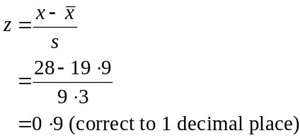

(1 mark)

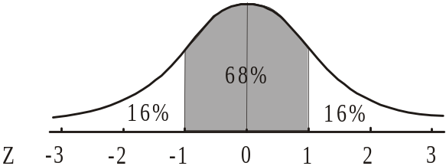

Since Lucy’s z-score was – 1, we see from the diagram that 16% of students scored less than Lucy so 84% scored a higher result than Lucy.
(1 mark)

Question 2

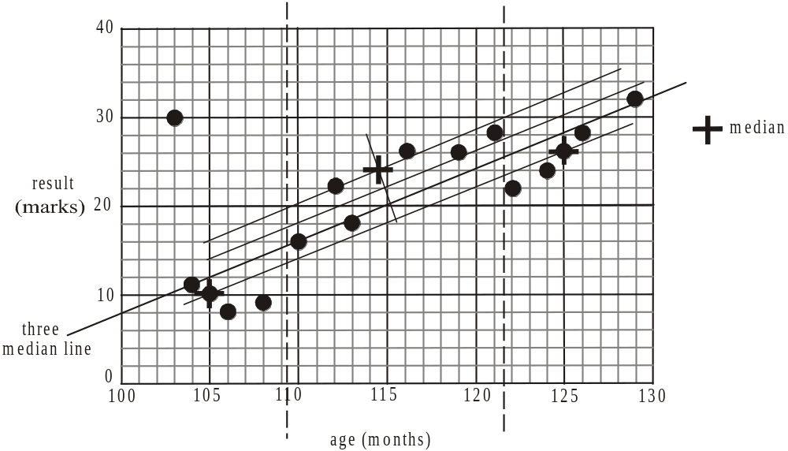

Divide the 16 points into 3 groups so that there are 5 in each of the outer groups and 6 in the middle group. The dotted lines indicate this grouping. Find the median in each of the 3 groups. The medians are located at (105, 10), (114.5, 24) and (125, 26). Place a ruler over the outer 2 medians and move it one third of the way towards the median in the centre group. This is the 3-median line.
(1 mark) correct medians
(1 mark) correct line shown

- Choose a section of any of the lines shown (since they are parallel) and find the rise and the run.
For example between the two outside medians 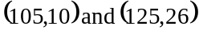 which lie on the line, the rise is 16 and the run is 20. The gradient is 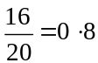.
(1 mark)

- For every 1 month increase in age there is an increase of 0.8 in the result. (This is governed by the gradient of the line.)
(1 mark)

Question 3

- It is appropriate to fit a least squares regression line to this data because the relationship between the variables age and result appears to be linear. (1 mark)
Secondly, there are no outliers in the data.
(1 mark)

- Using a calculator, we have

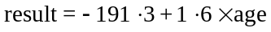

where the coefficients are correct to one decimal place.
(1 mark) for - 191.3
(1 mark) for 1.6

- i. Again from the calculator 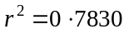 (correct to 4 decimal places)
(1 mark)

  - The coefficient of determinations tells us that 78.30% of the variation in the result can be accounted for by the variation in age.
(1 mark)
(Clearly the remaining 21.7% has to be explained by factors other than age.)

Total 15 marks

SECTION B

Module 1: Number patterns

Question 1

- jars remained after 3 hours.
(1 mark)

- so Paula will run out of jam after 6 hours.
(1 mark)

- The sequence is 84, 70, 56, 42, ….
This is an arithmetic sequence because the difference between each term is the same; that is, the difference is 14.
(1 mark)

- Note that the value is negative since each hour Paula has fewer jars left to sell.
(1 mark)

Question 2

- 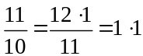 so the common ratio is .
(1 mark)

- Using a calculator, the amount of chutney Paula makes for the ninth market is 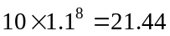kg (correct to 2 decimal places).
(1 mark)

- 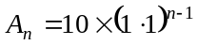
(1 mark)

- Again using a calculator start by multiplying 10 by .
At the 13th market the amount of chutney produced first exceeded 30kg.
(1 mark)

- The amount of chutney Paula makes in the first year in total is given by
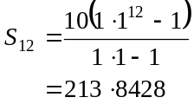
The amount of chutney Paula makes in the first two years in total is given by
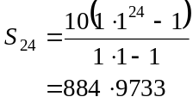 (1 mark)
In the second year therefore Paula makes
So the difference between what she makes in the first year and what she makes in the second year is .
(1 mark)

Question 3

- Since Paula makes 15% more fudge than she had to sell at the previous market, . (1 mark)
Since Paula keeps 200g of the fudge she makes for her family, .
(1 mark)

- Using a calculator, generate the sequence. The first time the sequence exceeds 3kg; i.e. 3000g is for where the amount made is 3220.2g.
So at the 15th market that Paula attends, 3kg is exceeded.
(1 mark)

- If Paula didn’t keep 200g of the fudge for her family the difference equation would be

.

This represents a geometric sequence.
(1 mark)

- The difference equation would be .
This is an arithmetic sequence.
The sequence is 1 600, 1 400, 1 200, 1 000, 800, 600, 400, 200, 0.
So the ninth market would be the one where for the first time Paula had no fudge to sell.
(1 mark)

Total 15 marks

Module 2: Geometry and trigonometry

Question 1

- The lookout at L is on a contour at 1700m. The shelter at S is on a contour at 1550m. The difference in height is 150m.
(1 mark)

- The contours to the north of the peak are the closest together and hence the land to the north of the peak is the steepest.
(1 mark)

- The average slope is given by
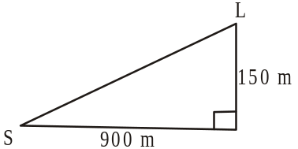
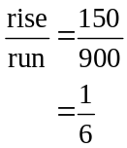
(1 mark)

Question 2
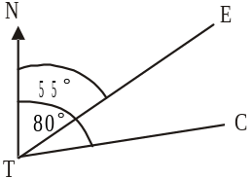
- The bearing of E from T is 055°.
The bearing of C from T is 080°,
So the angle ETC equals 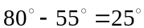.
(1 mark)

- In 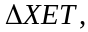
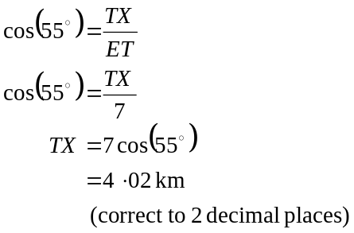
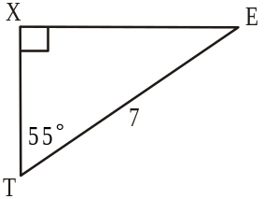
(1 mark)

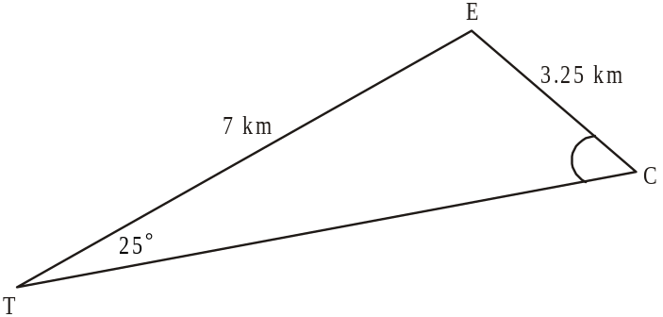

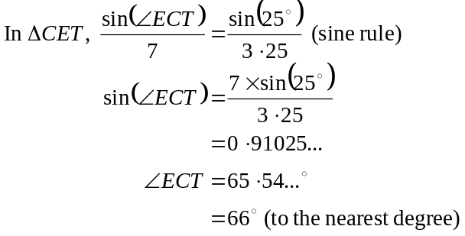
(1 mark)

d.
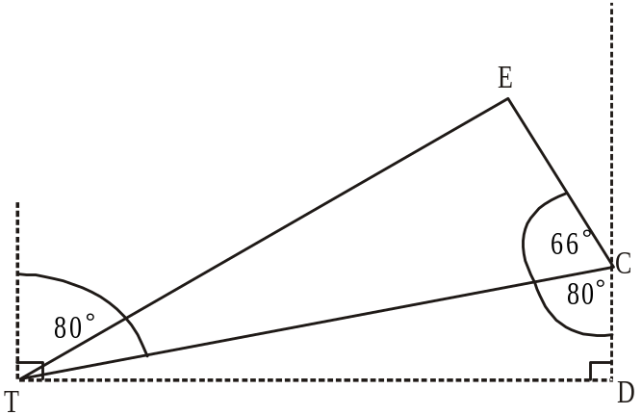

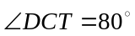 (alternate angles in parallel lines are equal).
So the bearing of E from C is equal to 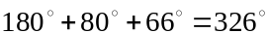.
(1 mark)

e.
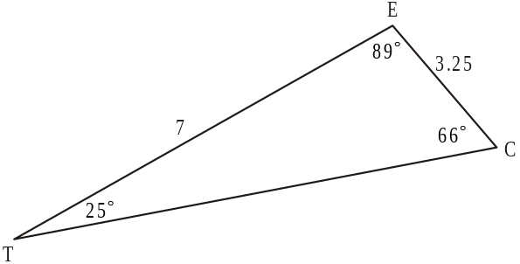

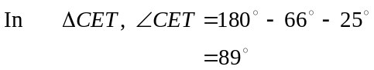 (1 mark)
Method 2 - using the sin rule
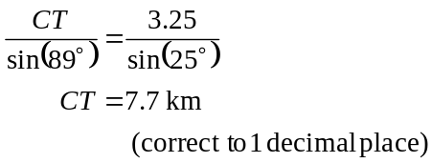
Method 1- using the cosine rule
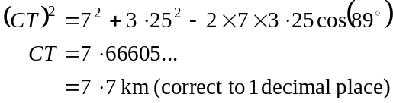

(1 mark)

Question 3
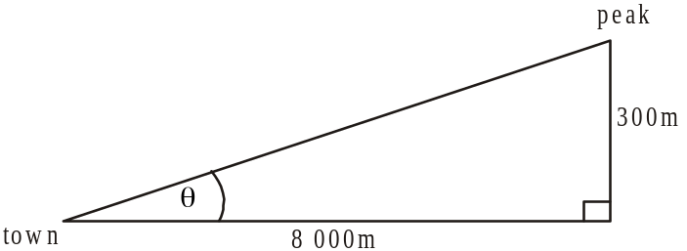
Let equal the angle of elevation.
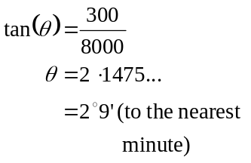
(1 mark)

Question 4
- Now we can use Heron’s formula to find the area of the slant side of a pyramid.

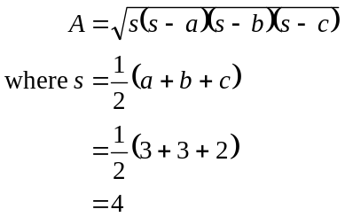
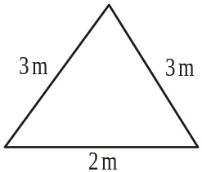
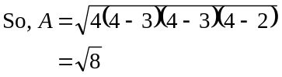
(1 mark)
So total surface area
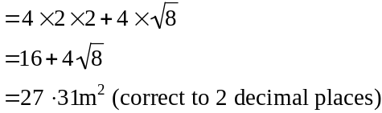
(1 mark)
b. The height of the cube is 2m.
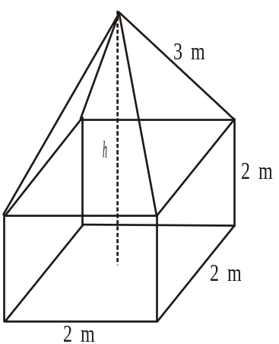

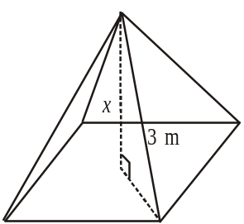

In the square pyramid, let the height be x. We know that the slant side is 3m. To find the length of the diagonal of the square base, use Pythagoras

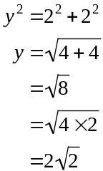
(1 mark)
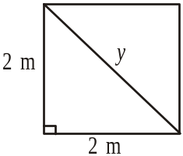

So the length of half the diagonal of the square base is 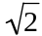m.
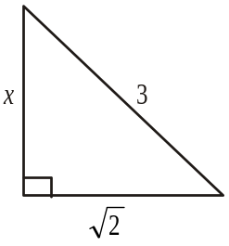

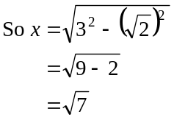

The height of the pyramid is 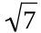m.
So the total height of the trig marker is 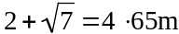 (to 2 decimal places).
(1 mark)
c.
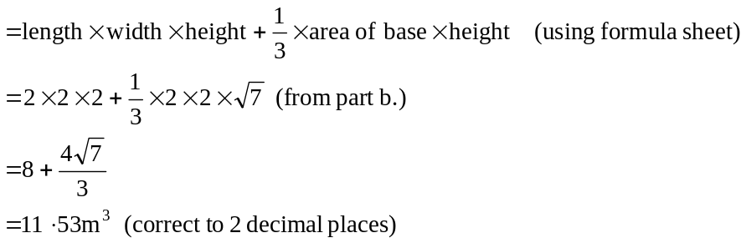
(1 mark)
Total 15 marks
Module 3: Graphs and relations.

Question 1

- The average weekly revenue received for each student who attends a class is given by the gradient of the revenue function.
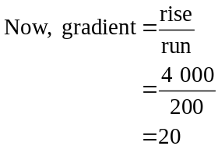
The answer is $20.
(1 mark)

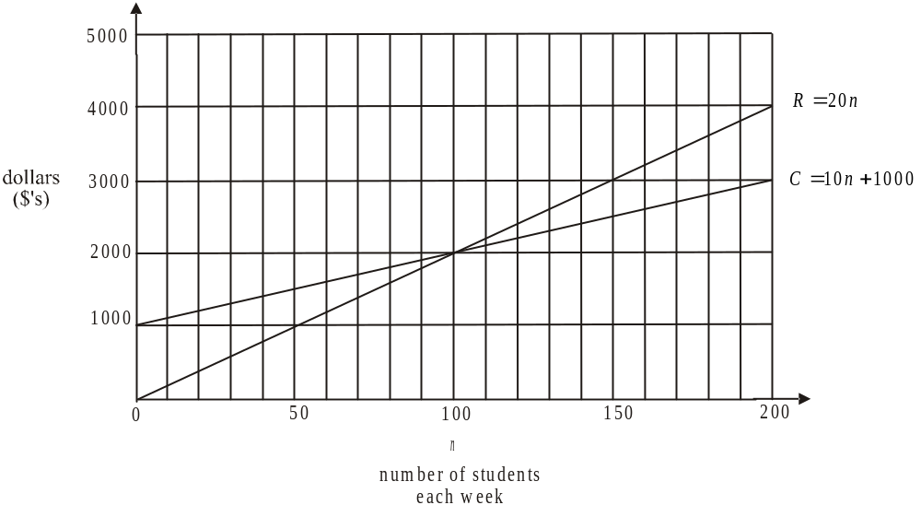

(1 mark)
- Method 1 - graphically
From the graph, the revenue function and the cost function intersect at 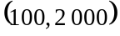 so the number of students required to achieve ‘break even’ is 100.
(1 mark)

Method 2 - algebraically
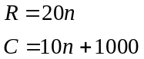
At break even point,
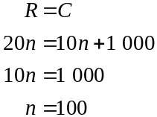
So the number of students required is 100.
(1 mark)

d. i.
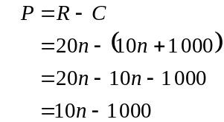
(1 mark)
  - Profit only occurs when revenue is greater than costs. This occurs when since at , there is break even point and for , the dance school is losing money.
The required inequation is 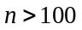.
(1 mark)
e. The maximum number of students that the school can teach in a week is 200.
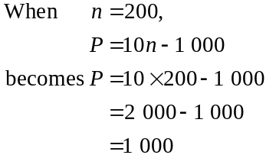
The maximum weekly profit is $1 000. (1 mark)

Question 2

- If you attend 4 classes per week you pay 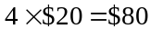 each week.
(1 mark)
- For 1 class you pay $30 in total per week,
for 2 the total is $50,
for 3 the total is $75,
for 4 the total is $80,
for 5 the total is $100,
for 6 the total is $90,
for 7 the total is $105,
for 8 the total is $80.
The maximum amount possible per week is $105. This is how much you pay in total in a week if you are attending 7 classes.
(1 mark)
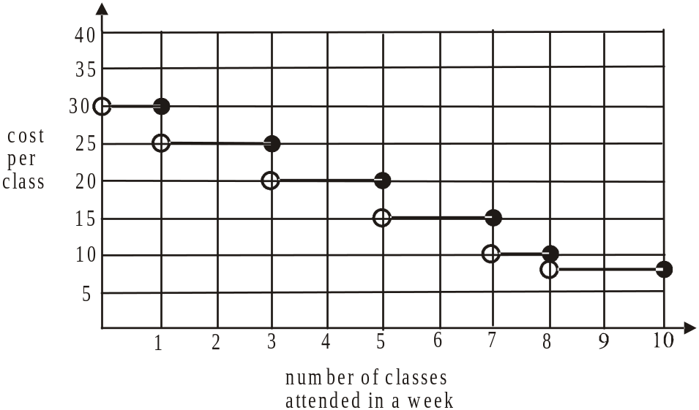

(1 mark)
Question 3

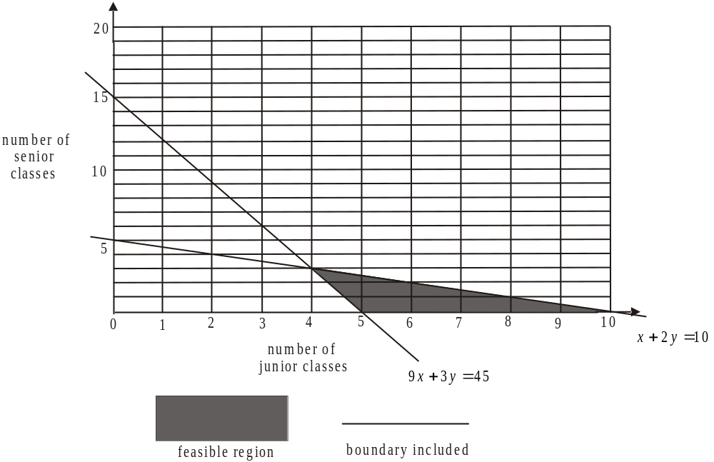

(1 mark) correctly showing boundary of 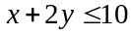
(1 mark) correctly showing feasible region
(1 mark) correctly indicating boundaries

- From the graph, the possible points, given that the coordinates have to be whole numbers, that is, they must represent the number of classes, are 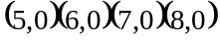
So there are 13 points.
(1 mark)

- 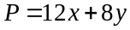.
(1 mark)

- Maximum profit will occur at one of the corner points of the feasible region.
From the graph, those corner points are located at 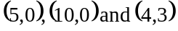.
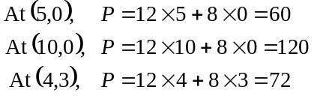
The maximum profit that could be made is $120.
(1 mark)
Total 15 marks

Module 4: Business-related mathematics

Question 1
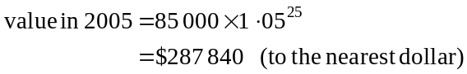

(1 mark)
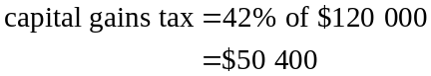

(1 mark)
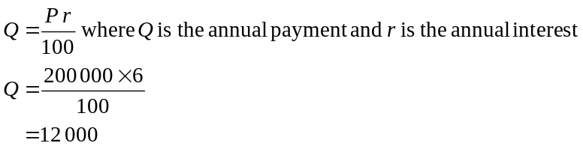
- i.

So Dawn receives $12 000 per annum which is 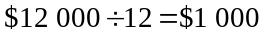 per month.
(1 mark)
ii. A monthly payment of $2 500 represents a yearly payment of
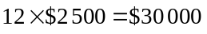
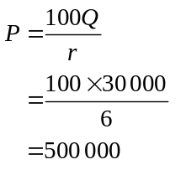
where P is the amount that needs to be invested to obtain a payment of $Q per annum where r is the annual rate of interest

(1 mark)
Dawn would need to invest $500 000.

Question 2
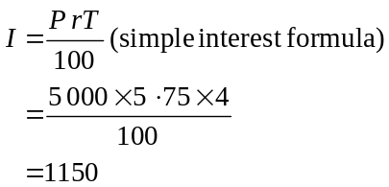

(1 mark)

Total investment is worth 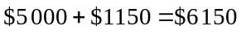.
(1 mark)
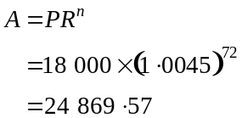
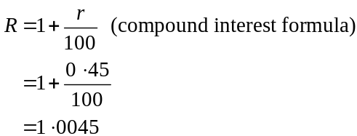

Note that annual interest of 5.4% represents monthly interest of .
Note also that over 6 years, with monthly calculations of interest, there are calculations of interest.
The investment is worth $24 869.57.
(1 mark)

- Since there are regular payments made, use TVM solver

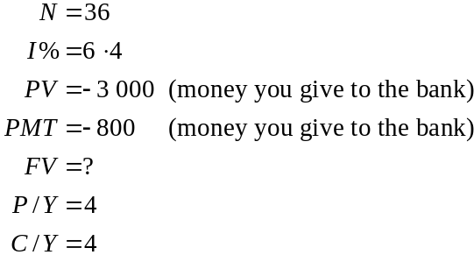
The future value i.e. after nine years will be $43 853.26.
So Juan’s investment after 9 years has a total value of $43 853.26.
(1 mark)

- Again, since there are regular payments; this time in the context of a loan, we can use TVM solver.

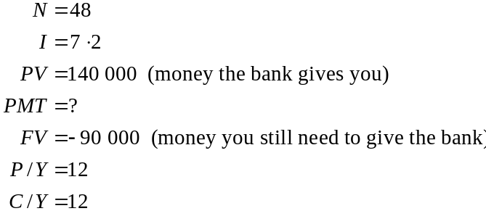
(1 mark)
They need to pay $1 741.96 each month.

- Again using TVM solver,
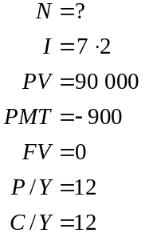
It will take 153.17 periods of 1 month. That is, it will take 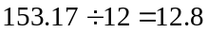 years (to one decimal place).
(1 mark)

Question 3

- The equipment is to be depreciated by . (1 mark)
Over 6 years, this represents an annual depreciation rate of 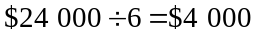 per year.
(1 mark)

- Using reducing balance depreciation, the value of the equipment V, is given by
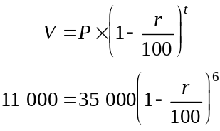
(1 mark)
Method 1 – using equation solver on a graphics calculator.
The equation to be solved is
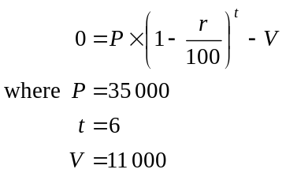
The value of r is given by 17.5442… So r = 17.5% (to one decimal place).
(1 mark)
Method 2 – by hand
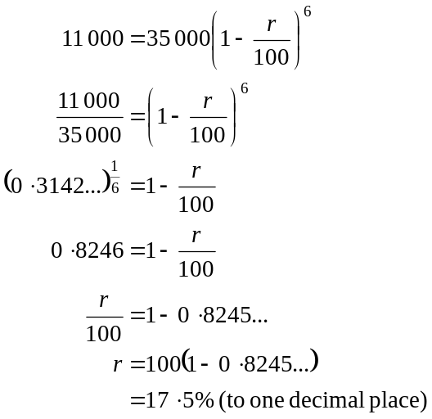
(1 mark)

- Using part a., after 1 year the equipment had a book value of (flat rate depreciation).
Using part b., after 1 year the equipment had a book value of 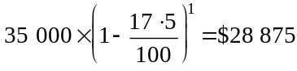 (reducing balance depreciation).
The difference is x where
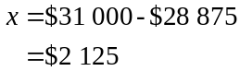
(1 mark)
(If answers to either a. or b. were incorrect, but used correctly in c. then the mark should be awarded.)
Total 15 marks
Module 5: Networks and decision mathematics

Question 1

- i. because Pat defeated Kate.
(1 mark)

- 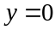 because Lou loses to Kate.
(1 mark)

- The one-step dominance score for Ricki is given by .
(1 mark)

- Looking at the dominance matrix we see that Pat defeated Kate and Kate defeated Lou. This represents a two-step dominance of Pat over Lou. There are no other two-step dominances of Pat over Lou so .
(1 mark)

- Lou defeats Ricki and Ricki defeats Kate. This represents a two-step dominance of Lou over Kate. Also, Lou defeats Pat and Pat defeats Kate. This represents a second two-step dominance.
In total there are two two-step dominances of Lou over Kate so .
(1 mark)

- The dominances are given by

 | one-step dominance score | two-step dominance score | one and two-step dominance score
Pat | 1 | 1 | 2
Kate | 1 | 2 | 3
Ricki | 2 | 2 | 4
Lou | 2 | 3 | 5
(1 mark)
From the one and two-step dominance scores we see that Lou is ranked first and Ricki is ranked second in this fitness competition.
(1 mark)

Question 2

 | Wing Attack | Centre | Wing Defence | Goal Attack
Claire | 3 | 2 | 2 | 5
Michelle | 2 | 1 | 3 | 1
Sue | 1 | 3 | 2 | 4
Kylie | 5 | 4 | 3 | 1

Subtract the minimum entry in each row from each of the entries in that row.
1 | 0 | 0 | 3
1 | 0 | 2 | 0
0 | 2 | 1 | 3
4 | 3 | 2 | 0
(1 mark)

The zero elements are covered and the minimum number of lines required to do this is four so we have an optimal allocation straight off.
Using a bipartite graph gives us the possibilities

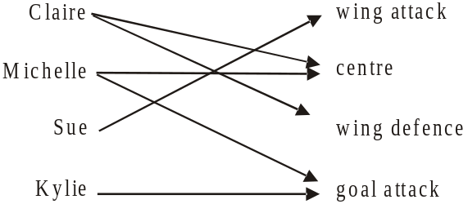

(1 mark)

The optimal allocation is:

Claire plays wing defence.
Michelle plays centre.
Sue plays wing attack.
Kylie plays goal attack.
(1 mark)
Note that Kylie can only play goal attack and Sue can only play wing attack according to the bipartite graph. This then determines where Claire and Michelle can play.

Question 3

- If the minimum time for the project to be completed is 12 weeks, then the length of the critical path is 12 weeks. Also since the earliest start time and the latest start time are the same for activity H and also for activity J, then they both lie on the critical path. So the length of activity J is weeks.
(1 mark)

- From part a. the critical path lies along activities A, D, H, J. The earliest start time and latest start time for activity H is 7. That means that activities H and J have a combined duration of 5 weeks. Since G and I don’t lie on the critical path, their combined duration must be less than 5 weeks so their maximum duration combined is 4 weeks.
(1 mark)

- If Activities A, C and I are of equal duration, and given that their combined duration is less than 12 weeks (because they don’t form a critical path) and also given that the duration for each activity is in whole weeks, then they could each have a duration of 3 weeks (total duration of 9 weeks) or 2 weeks (total duration of 6 weeks) or 1 week (total duration of 3 weeks). Any of these three answers is acceptable. So activity A could have a duration of 1, 2 or 3 weeks.
(1 mark)

- i. Activity E takes 3 weeks and activities H and J lie on the critical path and have a combined duration of 5 weeks. Therefore Activity E would have a latest starting time of 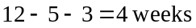.
(1 mark)

- Activity E has a latest starting time of 4 weeks and activity F has a latest starting time of 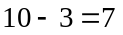weeks. Neither activities B, E or F lie on the critical path. Therefore the duration of B can be 1, 2 or 3 weeks (assuming that it is not 0 weeks). Note that if activity B had a duration of 4 weeks then activities B and E would then be on the critical path.
(1 mark)

Total 15 marks

Module 6: Matrices

Question 1

- 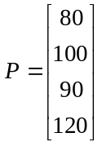
The order of matrix P is ; that is .
(1 mark)

b. The matrix product RP gives the total profit since R is a matrix and P is a matrix. The matrix product RP is a matrix. The matrix product PR multiplies a matrix by a matrix and gives a matrix.
(1 mark)
c.
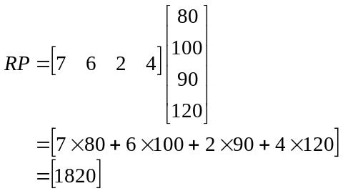
The profit is $1 820.
(1 mark)

Question 2

- 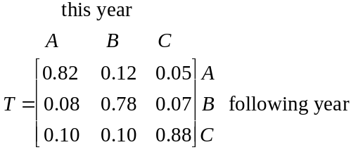
(2 marks)

- 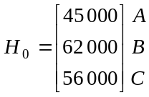
(1 mark)

- i. The matrix product is 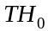.
(1 mark)
ii.
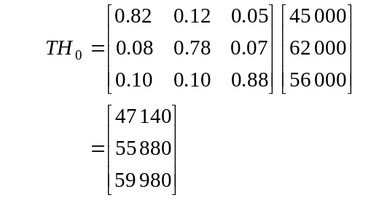
(1 mark)
- 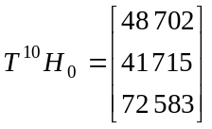

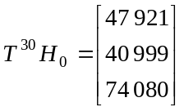
(1 mark)
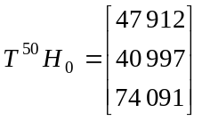

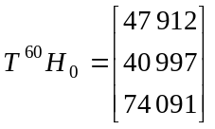
The last two matrices indicate that a steady state has been reached.
(1 mark)
(Note that two state matrices where the steady state has been reached – correct to the nearest whole number must be shown.)

Question 3

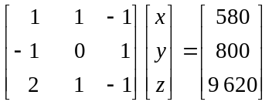
(1 mark)

- i. (using a calculator).
(1 mark)

  - Matrix B does not have a determinant because it is not a square matrix.
(1 mark)

- Now,
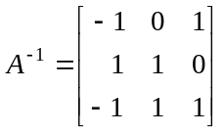
Also, (1 mark)
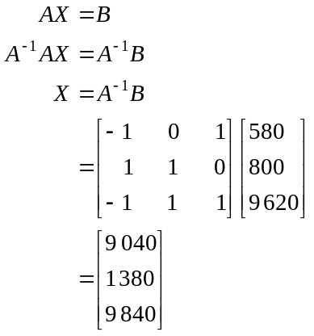
So 9 040 guests come for the scuba diving, 1 380 come for the golf and 9 840 come for the swimming.
(1 mark)
Total 15 marks

